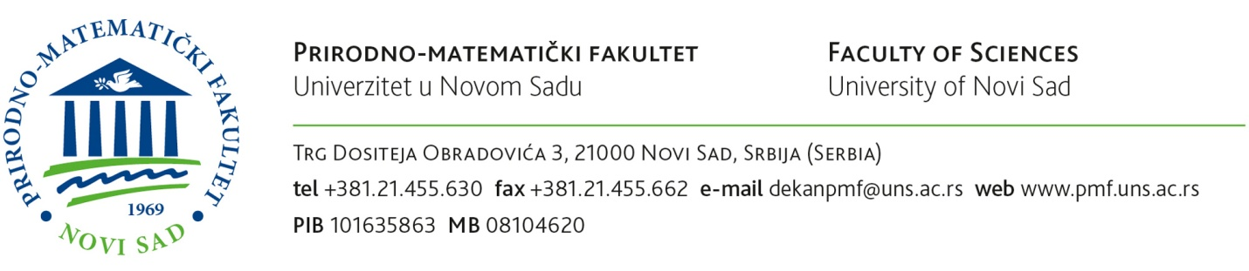

Based on the open competition for admission to PhD academic studies for academic 201__/201__ year, I herewith submit

APPLICATION

for enrolment in the Faculty of Sciences in Novi Sad, Department of ___________________________________
_______________________________________ to PhD academic studies, study programme of _________________________________________________________________________________________________________________ .

CANDIDATE’S PERSONAL INFORMATION

- Surname (father’s name) and first name: ___________________________________________________________________________
- Birth date:
________________________________________________________________________________________
- Place of birth, municipality (county) and country: ____________________________________________________________
- Nationality: ____________________________________________________________________________________________
- Gender (put X next to your choice): а) male b) female

- Data on previously completed bachelor academic studies
- Name of the higher education institution: _____________________________________________________
- Place of the higher education institution (city, country): _____________________________________
- Study programme/module: ____________________________________________________________________
- Year of enrolment: _____________________________________________________________________________
- Year of completing studies and graduation: __________________________________________________
- Duration of studies (in years and months): ____________________________________________________
- Grade point average during the studies: ______________________________________________________
- Number of ECTS acquired: ______________________________________________________________

7. Data on previously completed master academic studies
a) Name of the higher education institution: ______________________________________________________
b) Place of the higher education institution (city, country): ______________________________________
c) Study programme/Module: ______________________________________________________________________
d) Year of enrolment: ________________________________________________________________________________
e) Year of completing studies and graduation: _____________________________________________________
f) Duration of studies (in years and months): ______________________________________________________
g) Grade point average during the studies: _______________________________________________________
h) Number of ECTS acquired: _______________________________________________________________________

- Occupation: ___________________________________________________________________________________________
- Working position and institution: __________________________________________________________________
- Permanent address: __________________________________________________________________________________
- Contact phone number:
home:____________________; work:____________________________ ; mobile: ___________________________
12. Е-mail:

Together with this Application, the following is enclosed:

1. Certificate on previously completed bachelor academic studies or a confirmation of the Certificate: a) original b) certified copy
2. Certificate on previously completed master academic studies or a confirmation of the Certificate: a) original b) certified copy

3. Academic Transcript of Records with grade point average for bachelor academic studies
4. Academic Transcript of Records with grade point average for master academic studies
5. Curriculum of the previously completed study levels – for both bachelor and master for students outside the Faculty of Sciences
6. Birth certificate
7. Proof of the procedure fee payment

Novi Sad, date: ______________ 201__

Applicant:

________________________________
(signature)

IMPORTANT: ALL original documents in the Applicant’s native language (if other than English) need to be translated in English (or where required in Serbian) by a certified court interpreter to be accepted as eligible.
Certificate(s) on completed undergraduate studies needs to be recognized in order to continue studies at the University of Novi Sad. This procedure is done by the University of Novi Sad and it may take some time. Applicants are strongly advised to submit the documents as soon as possible. It is possible to get the written confirmation that the procedure is started in order to enclose it in the application together with other documents.
For more information visit: www.uns.ac.rs
Contact email: priznavanje@uns.ac.rs; rektorat@uns.ac.rs
Highly recommended to call: +381 21 485 2021
The Application should be duly filled in, signed by the Applicant and emailed (as an attached scan) to the following email address: gordanav@uns.ac.rs
OR submitted in person until 7 October 2017 at the latest.*
Final ranking list will be published until 13 October 2017 at the latest.*
Enrolment deadline is from 18 - 24 October 2017*

*Please bear in mind that dates may vary. Be sure to check for updates prior to submission.

